Demand and supply curves
- A hurricane in South Carolina damages the cotton crop
When a hurricane damages the cotton crop, the supply of sweatshirts will decrease because the raw materials (cotton) will have reduced. With decreased supply, the prices of the sweatshirts is bound to increase (the equilibrium price increases). Increase in price reduces the demand for the sweaters. Therefore the supply curve will shift to the left as shown below.
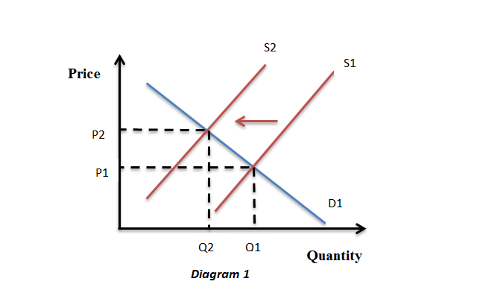

- The price of leather jackets fall
Leather jackets are substitutes of sweatshirts. A decrease in their prices means that customers will buy the leather jackets instead of sweatshirts because they are cheaper. This means that the demand for sweatshirts will decrease. A decrease in demand will trigger a corresponding decrease in the equilibrium price and quantity of the sweatshirts. The quantity will therefore decrease. The demand curve therefore shifts to the left.
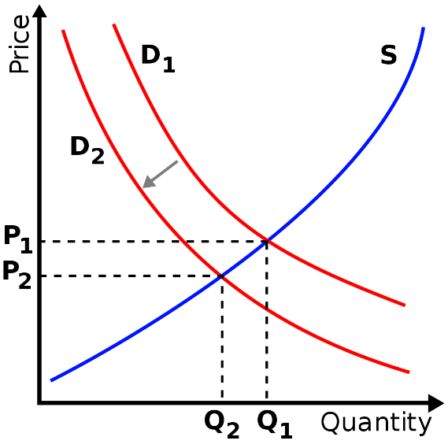

- All colleges require morning exercise in appropriate attire
Heavy clothes are not advisable to wear when exercising. Since sweatshirts are heavy clothes, if the college requires students to wear appropriate attire for doing exercise, the students will go for light clothes. This means that the demand for sweatshirts will decrease. A decrease in demand for sweatshirts will lead to decrease in the equilibrium price. The quantity of the sweatshirts will also decrease. The demand curve therefore moves to the left.
- New knitting machines are invented
New knitting machines will make it easy to produce sweatshirts. Therefore, there will be massive production of the clothes. Thus, the supply will increase and the price will decrease. Decrease in price will in turn lead to increase in demand. Increase in supply leads to increase in demand. The supply curve shifts to the right as shown in the diagram below.
